According to the following upgrade process,users who cannot upgrade normally,please contact the manufacturer in time.

1. U disk format should be FAT32 format.

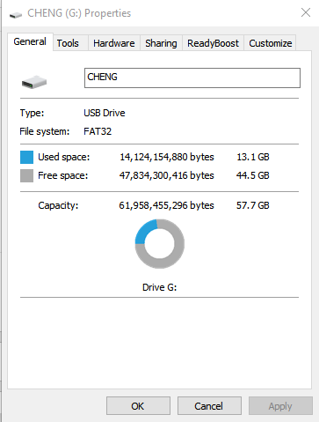

1. Copy and paste the "ET3916_UPDATE" folder to the root directory of the USB drive

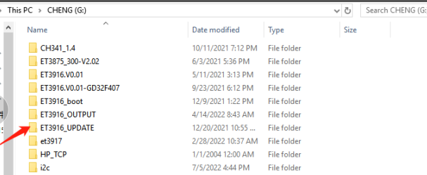

1. Insert the U disk in the device, enter the system settings interface, select the program upgrade, and press the ETNER key

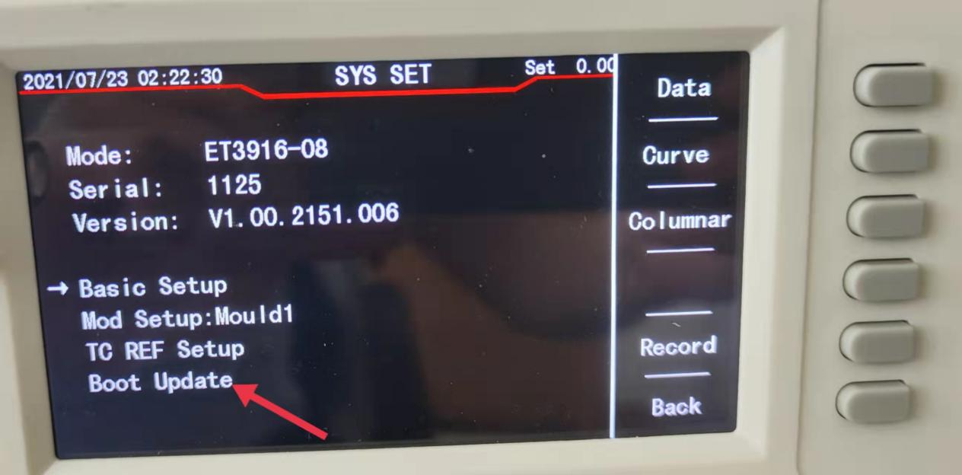

1. Enter the program upgrade interface, press ENTER according to the prompts, and start to import the upgrade program (it takes about 10 seconds or less).

If there is no response when you press the ENTER key, or if the device reboots continuously after inserting the U disk, please replace the U disk, or contact the manufacturer.

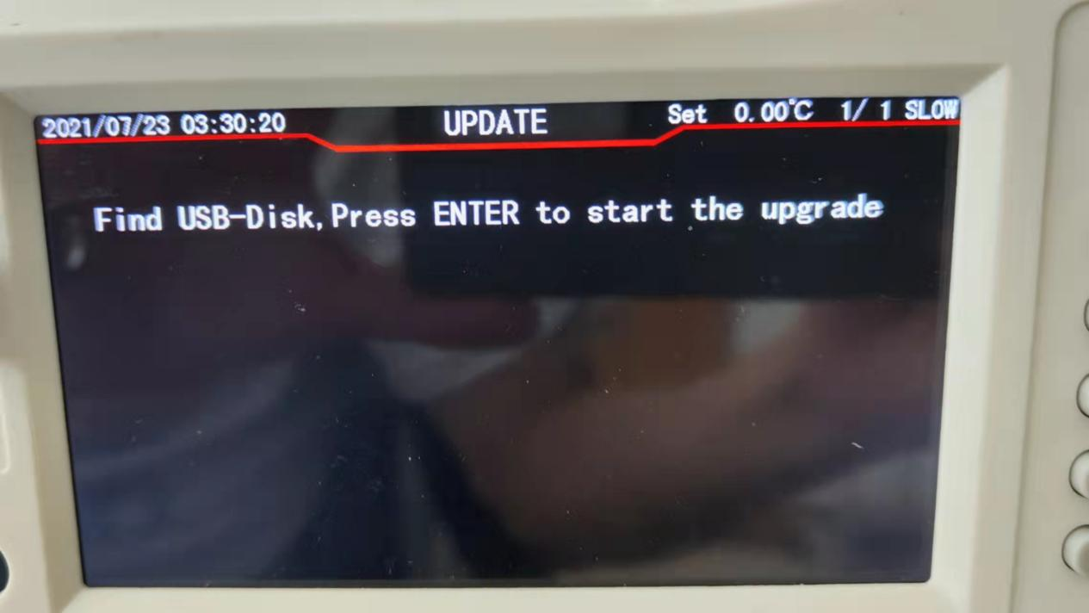

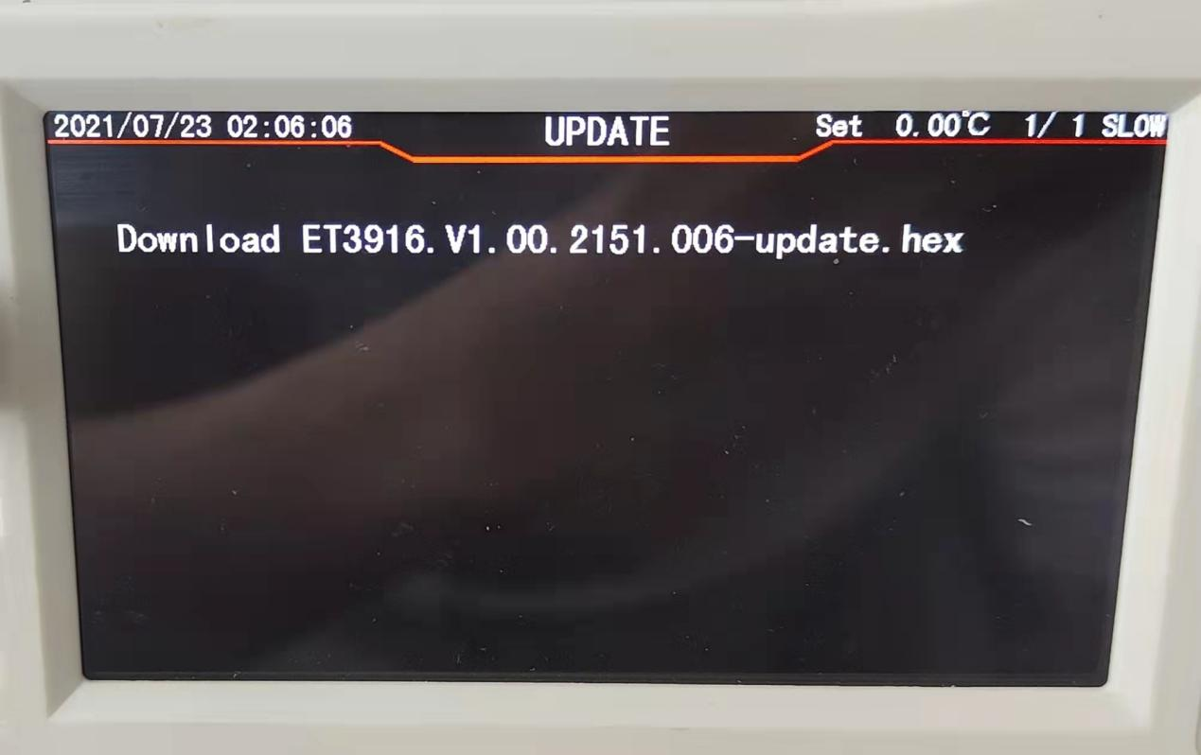

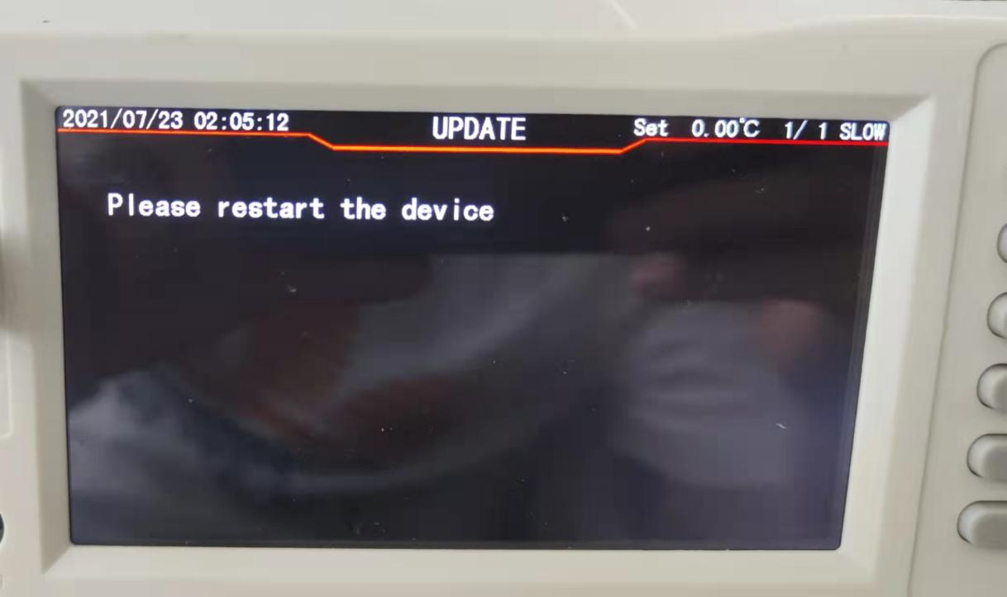

1. Reboot the device according to the prompts, and the program will be updated automatically after the reboot, and the device will be up and running normally after the update is completed

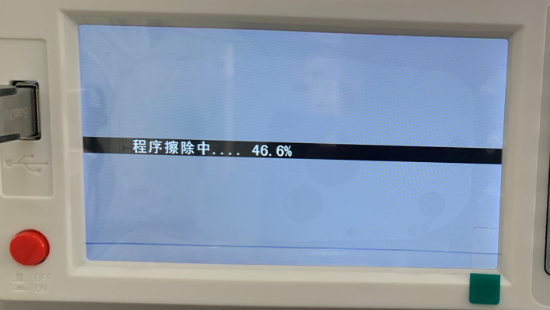

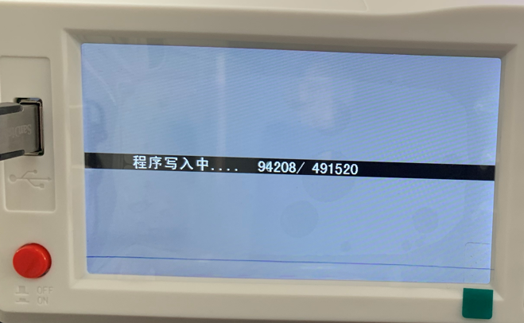

if update over ,pls start the meter ,if the screen cant light ,pls press number 1 and number 7 together for start the meter