Function signal generator waveform editing software operation

Decompression software
Unzip the compressed file "Arb Tool.rar" to get the waveform editing software.

Open the waveform editing software
After decompression, select ZCArb.exe in the file directory. Double-click, or right-click to open.
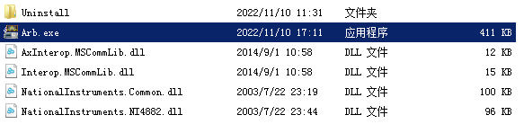
Figure 2-1 Catalog and selection software

Setup software
After opening the software, you will be prompted to choose the model, press the default option, and click OK. Then enter the sampling rate and horizontal length settings. Set the sampling rate to 200.0000000000Msa/s, and the waveform length to 8192 points.
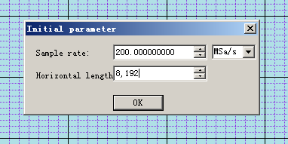
Figure 2-1 Sampling rate and horizontal length settings

Edit waveform
The waveform editing menu bar can edit the waveform.
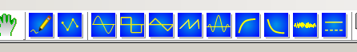
4-1 Waveform edit menu bar
Take the sine wave as an example, click the icon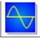，The following interface pops up.
It should be noted that the number of set points is 8192, the high is 32767, and the low is -32767.
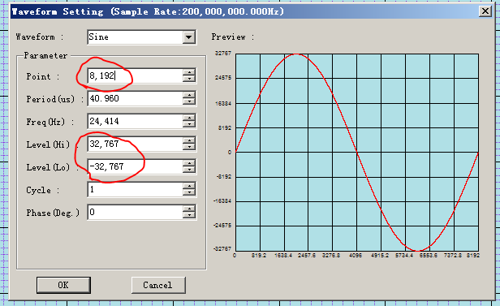
图4-2Waveform Generation Settings
click icon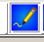
You can draw the waveform at will, as shown in Figure 4-3.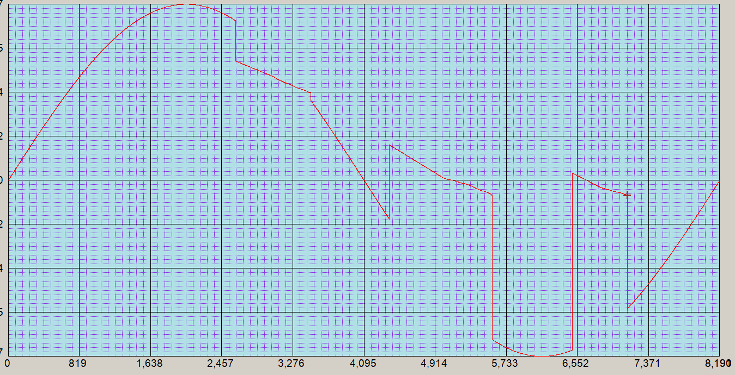
图4-3 Brush to edit waveforms arbitrarily

5. Download waveform
Device connection rear panel square port USB
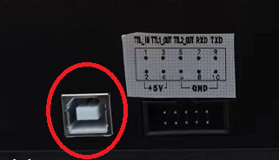
Figure 5-1 Connecting to the serial port
Find the CH340 device in the device manager, and the correct COM port.
If you can’t find CH340, you need to install the driver of CH340/CH341 in the CD, and then open the device manager to find the COM port.
Figure 5-2 Device Manager to find the correct COM port

Then click the rightmost icon in the upper right corner and select the correct COM port.
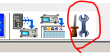
图5-3 Match COM port
The following window will pop up, subject to the port of the device manager, here is COM15.
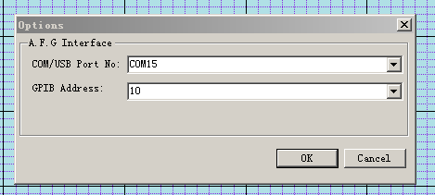
图5-4 Select the correct COM port
Then click the leftmost icon in the upper right corner to start sending the edited data.
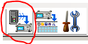
Figure 5-5 Sending waveform data

Set the starting point to 0, the length to 8192, and then press "Send" to send the waveform data.
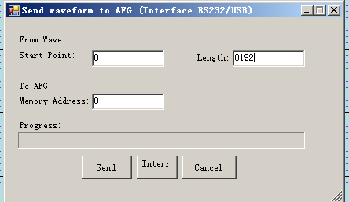
Figure 5-6 Send Waveform Options

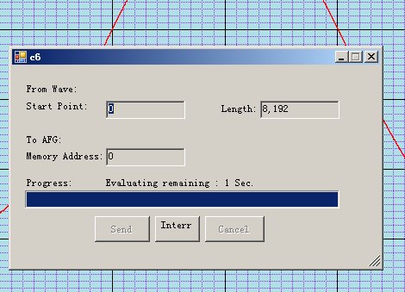
Figure 5-7 Waveform data sent successfully

loaded volatile wave
After the download is successful, the main channel of the basic waveform interface will directly become a volatile wave.
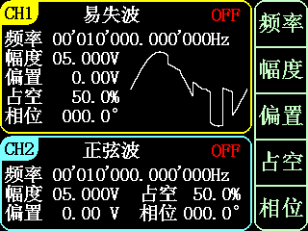
Figure 6-1 Volatile wave interface
Output the waveform, and you can directly see the waveform on the oscilloscope. It is consistent with the waveform depicted in "Figure 4-3 Waveform Edited Anywhere with a Paintbrush".
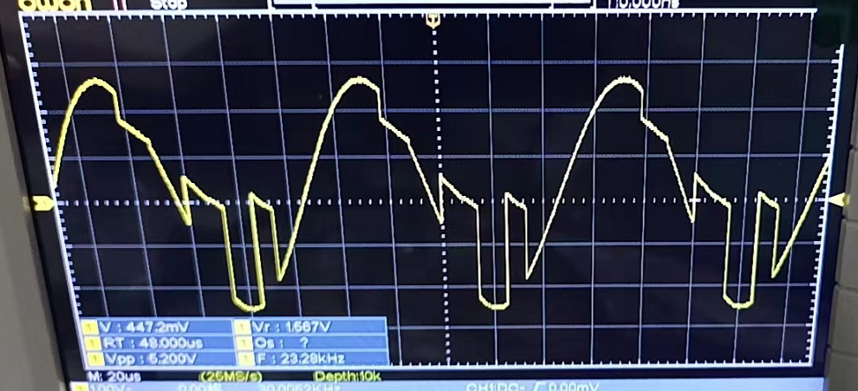
6-2 Oscilloscope observation of volatile waveforms

6. Save volatile waves
Each download of a waveform is one-time, and volatile waves are waves that are easily lost.
。Every time the power is turned on and restarted, the volatile wave will disappear.
Every time a new volatile wave is written, the old volatile wave disappears.
Press the SYS key to select arbitrary waveform. Select the arbitrary waveform position to be saved and press Save to save the waveform of the current main channel to the arbitrary waveform at the corresponding address.
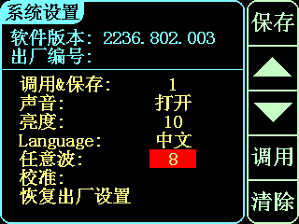
图7-1 Save volatile waves

At this time, the waveform of the main channel is a volatile wave, and the selected arbitrary wave position is arbitrary wave 8. So you can see that the volatile wave of the main channel is saved to arbitrary wave 08. In the main interface, select arbitrary wave 08, and you can see arbitrary wave 08, which is the waveform of the previous volatile wave.
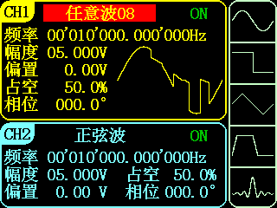
Figure 7-1 View the saved waveform

